AI Assisted Coding
Name:K.Srinija
Htno:2303A52474
Batch : 39

1.Write a Python function that checks whether a given integer is a palindrome number.
The function should take one integer as input and return a clear message indicating whether the number is a palindrome or not.
Code:
def ispalindrome(number):
# Convert number to string
original = str(number)
# Reverse the string
reversed_number = original[::-1]
# Compare original and reversed values
if original == reversed_number:
return True
else:
return False
def main():
print(" palindrome number")
try:
# Taking input from the user
user_input = input("Enter a number: ")
# Checking if input is numeric
if user_input.lstrip('-').isdigit():
number = int(user_input)
# Negative numbers are not palindromes
if number < 0:
print("Negative numbers cannot be palindrome.")
else:
# Function call
result = is_palindrome(number)
if result:
print(f"{number} is a Palindrome Number.")
else:
print(f"{number} is NOT a Palindrome Number.")
output:
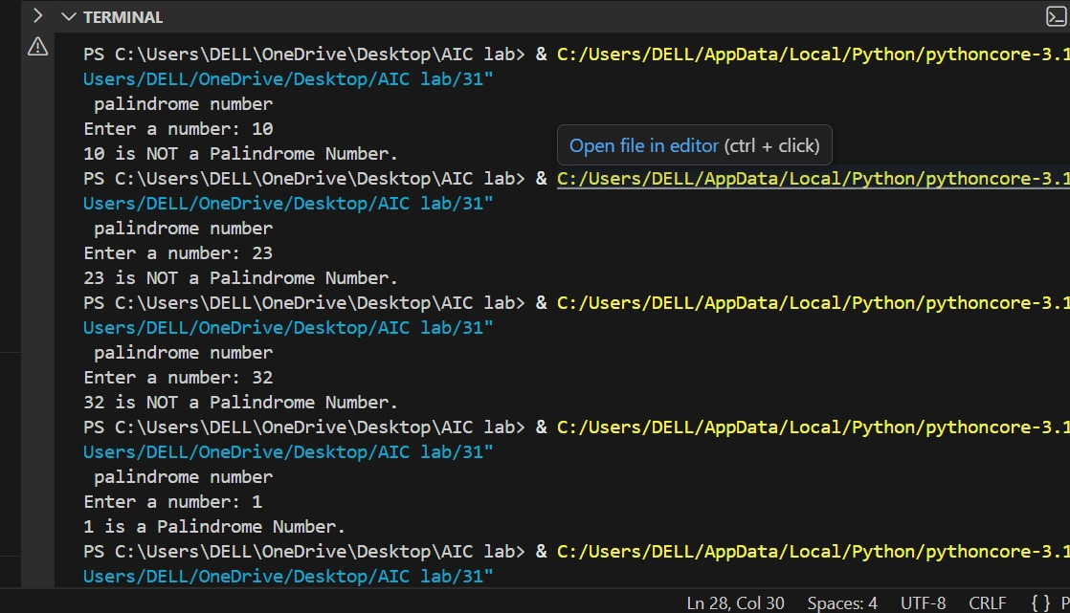
In this question, zero-shot prompting was used, where no examples were provided to the AI model. The AI relied entirely on its pre-trained knowledge to generate the palindrome-checking logic. The generated solution correctly followed the idea of reversing the number and comparing it with the original value
2.Write a Python function to calculate the factorial of a given non-negative integer.
Code:
ef factorial(n):
result = 1
for i in range(1, n + 1):
result = result * i
return result
def main():
print("FACTORIAL CALCULATOR")
try:
num = int(input("Enter a non-negative integer: "))
if num < 0:
print("Factorial is not defined for negative numbers.")
elif num == 0:
print("Factorial of 0 is 1.")
else:
fact = factorial(num)
print(f"Factorial of {num} is {fact}")
except ValueError:
print("Invalid input! Please enter an integer.")
except Exception as e:
print("Unexpected error:", e)
main()''

output:
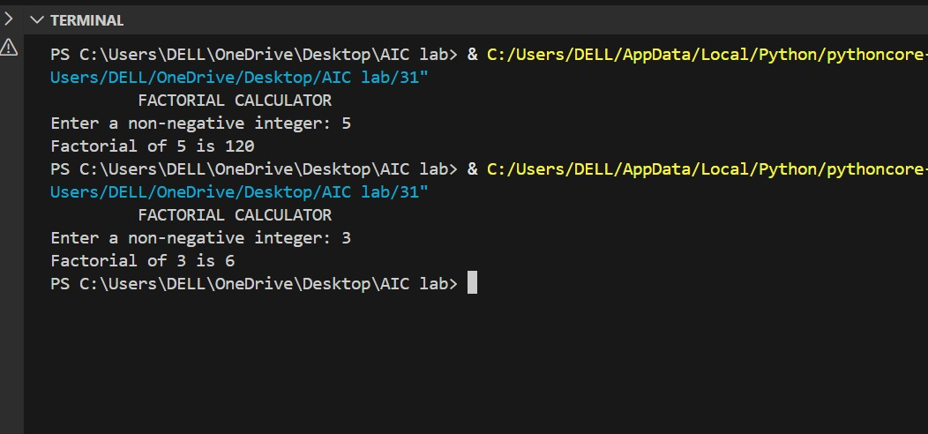
Analysis:
In one-shot prompting, a single input-output example (Input: 5 → Output: 120) was provided. This example helped the AI clearly understand the expected behavior of the program. Compared to the zero-shot approach, the generated factorial program showed improved clarity and correctness.

3. Write a Python function that checks whether a given number is an Armstrong number.
An Armstrong number is a number that is equal to the sum of its digits raised to the power of the number of digits.
Code:

'''def is_armstrong(number):
temp = number
digit_count = len(str(number))
total = 0
while temp > 0:
digit = temp % 10
total += digit ** digit_count
temp //= 10
if total == number:
return True
else:
return False

def main():
print(" ARMSTRONG NUMBER ")
try:
user_input = input("Enter a positive integer: ")
if user_input.isdigit():
number = int(user_input)
if number <= 0:
print("Please enter a positive integer.")
else:
if is_armstrong(number):
print(f"{number} is an Armstrong Number.")
else:
print(f"{number} is NOT an Armstrong Number.")
else:
print("Invalid input! Only numbers are allowed.")
except Exception as e:
print("Error occurred:", e)
main()
output:
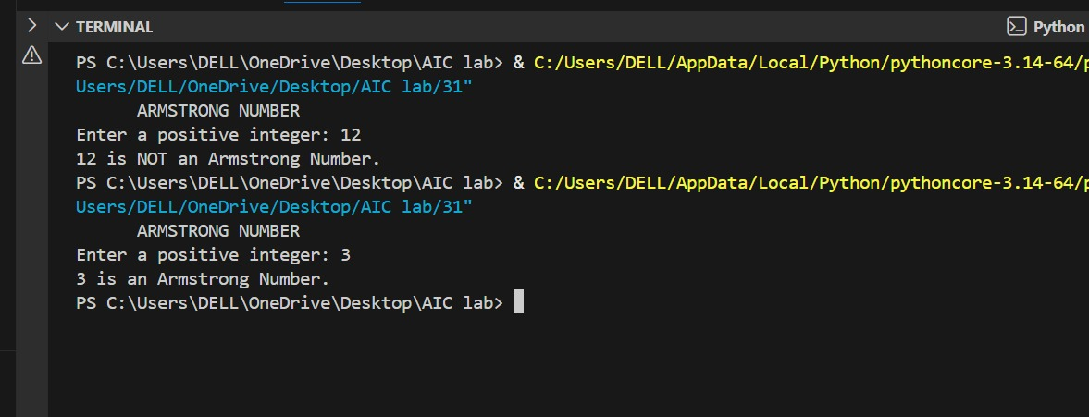
Analysis:
Few-shot prompting was used by providing multiple examples of Armstrong and non-Armstrong numbers. These examples helped the AI clearly understand the mathematical definition and pattern of Armstrong numbers.
4. write a Python program that classifies a given integer as Prime, Composite, or Neither.
Code:
'def is_prime(number):
if number <= 1:
return False
for i in range(2, int(number ** 0.5) + 1):
if number % i == 0:
return False
return True
def main():
print(" NUMBER CLASSIFICATION TOOL ")
try:
num = int(input("Enter an integer: "))
if num <= 1:
print(f"{num} is Neither Prime nor Composite.")
else:
if is_prime(num):
print(f"{num} is a Prime Number.")
else:
print(f"{num} is a Composite Number.")
except ValueError:
print("Invalid input! Please enter a valid integer.")
except Exception as e:
print("Unexpected error:", e)

main()
def count_even_odd(numbers):
even_count = 0
odd_count = 0
for num in numbers: # Loop through each number in the list
if num % 2 == 0: # Check if the number is even
even_count += 1
else: # If not even, it must be odd
odd_count += 1
return even_count, odd_count;
output:
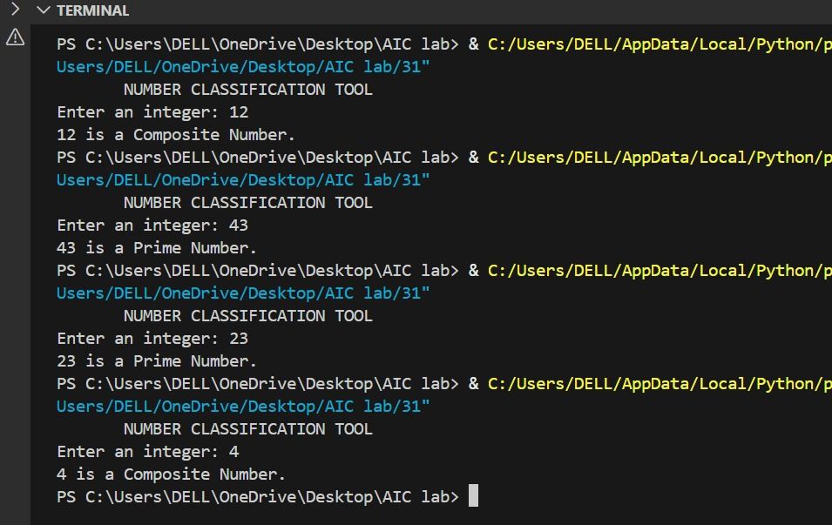
Analysis:
This question used context-managed prompting by explicitly stating constraints such as input validation, optimization, and efficiency. The AI generated a well-structured and optimized solution using square-root logic for prime checking.
5. Write a Python function that determines whether a given number is a perfect number.
A perfect number is a positive integer that is equal to the sum of its proper divisors excluding itself.
Code:
def check_even_odd(number):
if number % 2 == 0:
return "Even"
else:
return "Odd"
def main():
print(" EVEN OR ODD ")
try:
user_input = input("Enter an integer: ")
if user_input.lstrip('-').isdigit():
number = int(user_input)
result = check_even_odd(number)
print(f"The number {number} is {result}.")
else:
print("Invalid input! Please enter an integer.")
except Exception as e:
print("Error:", e)
main()
output:
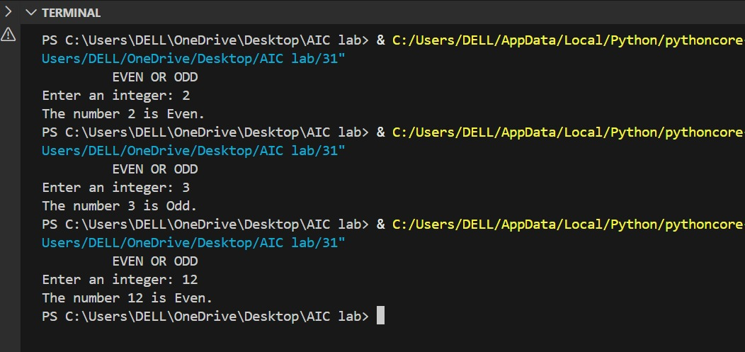

Analysis:
Similar to Question 1, zero-shot prompting was used without examples. The AI correctly implemented the logic of summing proper divisors to check for a perfect number.

